*Application*

User guide and documentation

Version *1.0*

*01/19/2019*

# SCATS Application User Guide and Documentation

## How Do I?

### Get started using SCATS

### Manage SCATS system users

### Add a new security consultant

### Manage security consultants and certifications

### Add a new security engagement

### Manage security engagements

### Generate data reports

### Get started using SCATS

Download the SCATS Installer for your required platform from the Cygiene Solutions website. Run the installer and launch the application by double clicking on the shortcut.

### Logging In

When the SCATS Application launches, a login prompt will be displayed. Use the following default credentials to access the application:

**Username**: admin **Password**: admin

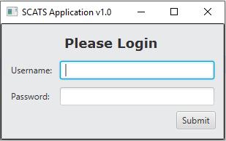

### General Interface and Navigation

The SCATS application is a Security Consultant Assignment/Engagement Tracking System. Its primary functionality is to manage existing engagements, their assigned consultants, as well as the qualifications of consultants via their earned certifications.

The primary SCATS Application Interface is an interactive Calendar that displays the start dates of active Engagements being tracked within the system. Active engagements are represented at the bottom of the main SCATS Application Interface in the Active Engagements table. This table provides important information used to manage and appropriate schedule security assignment and engagements.

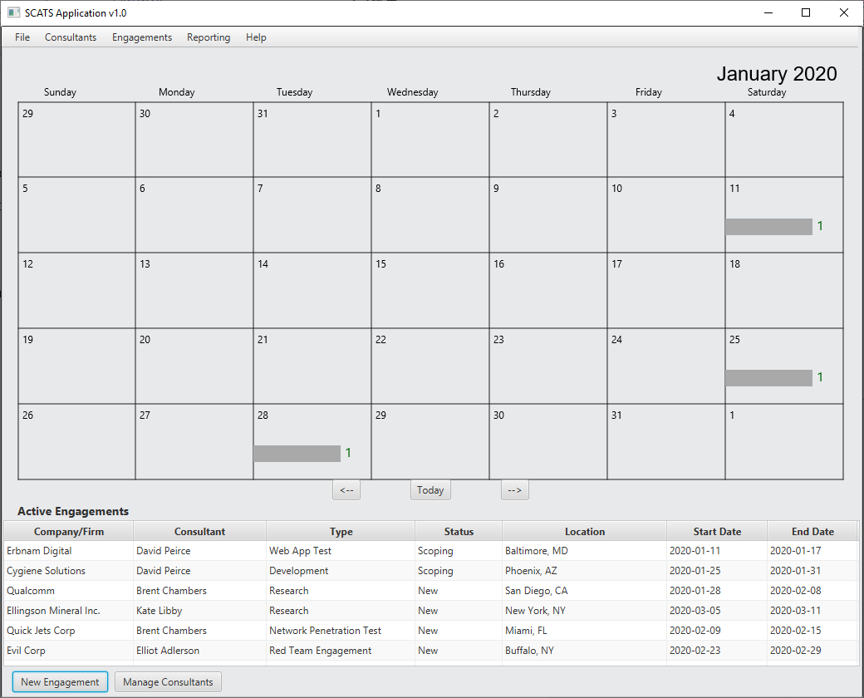

The SCATS Application’s Interactive Calendar is used to visually represent the start date of active security engagements. Engagements scheduled to begin on a specific date are denoted by a rectangular marker within the calendar date and a value representing how many engagements are scheduled to start.

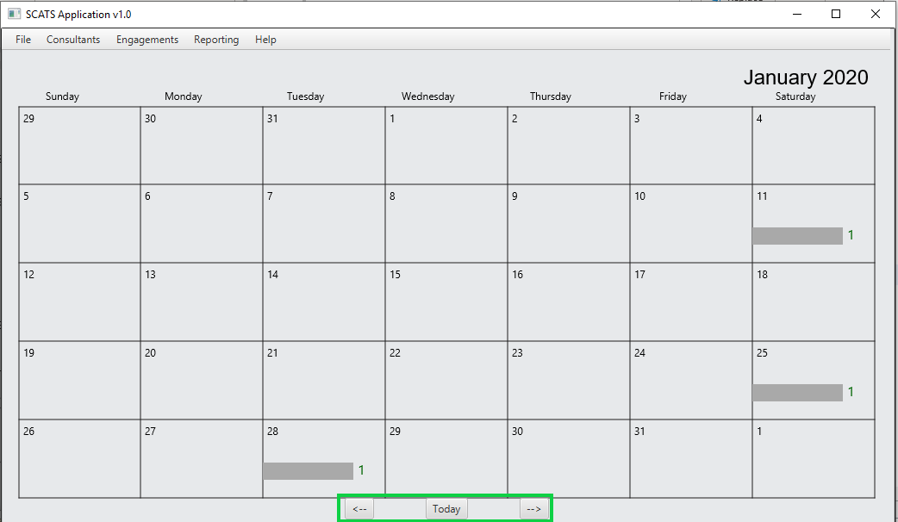

Upon clicking a date marker, an engagement management table will detail the engagements starting on that date.

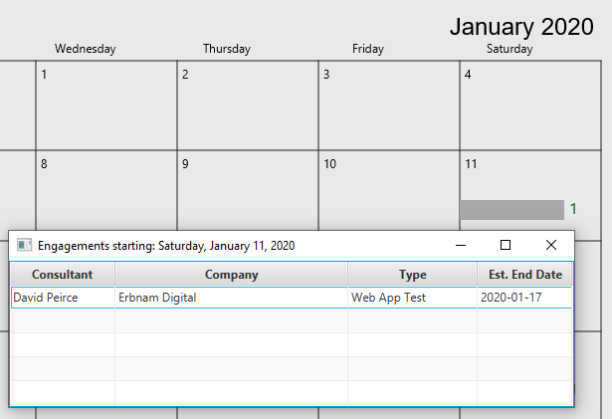

### Manage SCATS system users

SCATS system users can be managed by navigating to File -> Manage Users

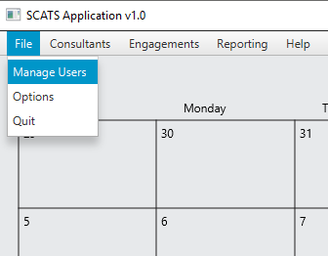

This will open the Manage Users dialog box, which allows you to create a new user, edit, or delete an existing user.

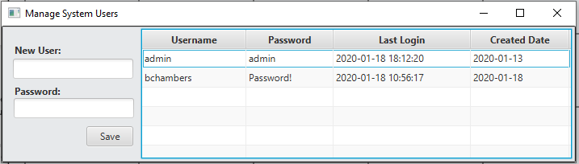

To create a new user, simply supply the New User field with a username, and the Password field password with at least 8 characters, and click Save.

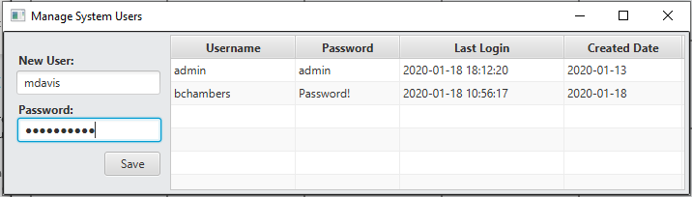

A successfully created system user will show up in the System User’s table.

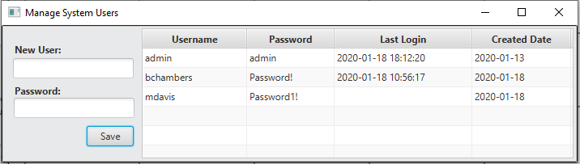

The new user will not contain a Last Login value as the user has not yet authenticated to the SCATS system.

To change the username or password of an existing user, right click on the record within the System User’s Table and select “Edit User”.

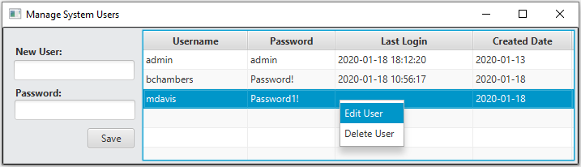

An Update System User dialog will be displayed. Update the Username and/or Password as appropriate, and click Save, to make the changes.

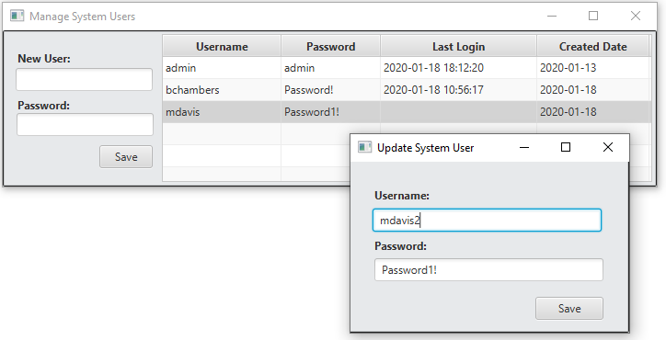

The changes to the User will not be reflected in the Manage User’s Table until the Manage System User’s window is closed, and reopened.

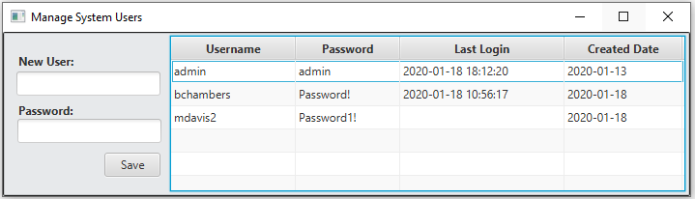

### Add a new security consultant

A new security consultant can be added to the SCATS System by navigating to the primary menu bar and selecting Consultants 🡪 New Consultant.

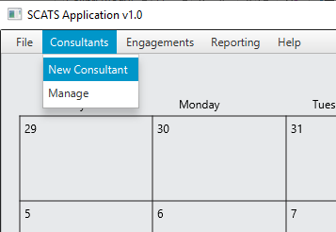

A new consultant only requires a name, a primary location, and a hire date. A description of the consultant can be added as well, but it is optional upon initial creation. Once a Name, Location, and Hire Date are selected, click Save.

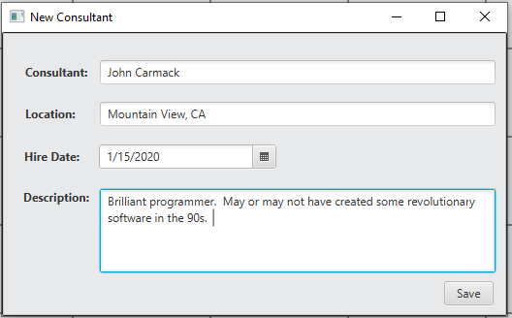

Consultants are managed within the Manage Consultants tool found by clicking on Consultants -> Manage, from the main screen menu bar.

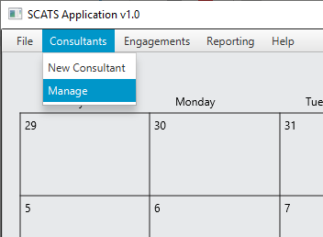

### Manage security consultants and certifications

The Manage Consultants tool lists all active consultants within the database and the location from which they are primarily based. Management actions to take on each consultant are performed by right clicking on their individual consultant records.

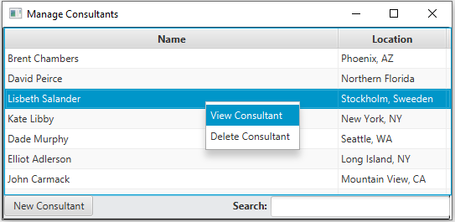

Once a consultant is created and essentially onboarded into the program, additional details of their skills and qualifications may be required. To view or provide more information about a consultants’ skillset, credentials and qualifications, right click their Consultant record and choose “View Consultant”.

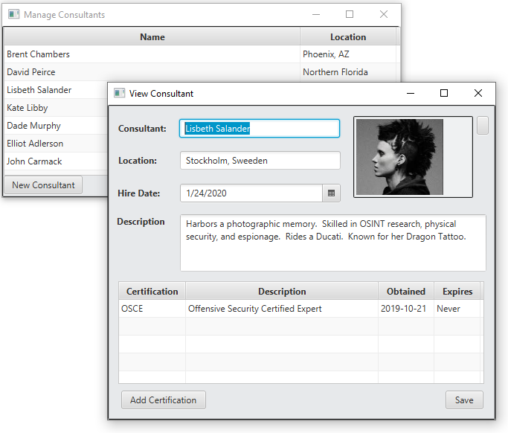

The Consultant’s description and certifications are displayed in the “View Consultant” dialog. Changes in the Consultant, Location, or Hire Date fields are made only after the SAVE button is clicked. Changes made to the Consultant’s profile image or certification list are made persistent immediately. To update a Consultant’s profile picture, click the button next to the profile image and select an appropriate image file.

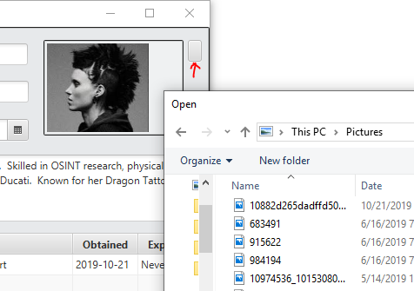

### Manage security certifications

One of the primary features of the SCATS application is to track security certifications obtained by Security Consultants to ensure consultants are assigned work within their field of expertise. Certification management is handled within the “View Consultant” dialog per each consultant, where earned or obtained certifications are housed in a table associated with that consultant. To add a certification to a consultant’s profile, click the “Add Certification” button.

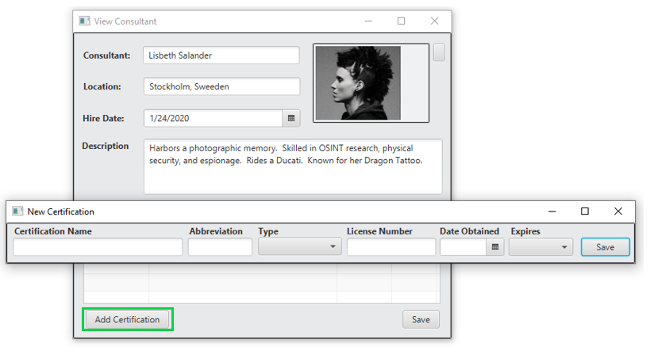

A New Certification dialog will require a Certification Name, Abbreviation, Type, License Number, Obtained Date, and Expiration selection to be saved to the consultant’s profile.

Certifications can be updated and deleted by right-clicking on the Certification item within the Certification table of View Consultant.

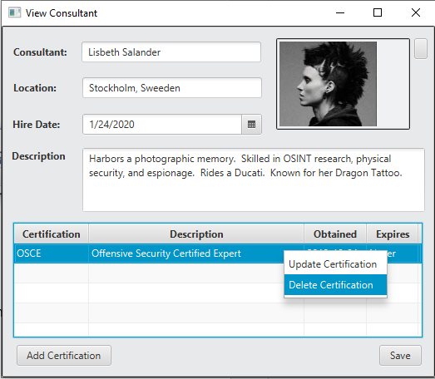

### Add a new security engagement

Managing security engagements is the core functionality of the SCATS application. New engagements can be created using the “New Engagement” button at the bottom of the primary SCATS application interface, or by selecting “New Engagement from the main menu bar by navigating to Engagements -> New Engagement.

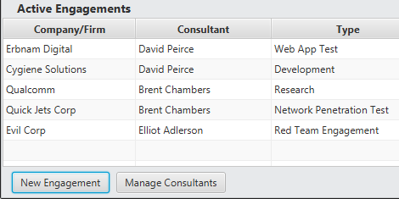

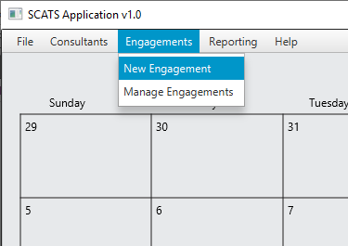

The “New Engagement” dialog will provide the necessary fields to populate in order to generate a New Engagement to be tracked within the SCATS system. At a minimum, a new engagement requires a Location, Company/Firm, Engagement Type, as well as Start and End date estimations for the required Fieldwork.

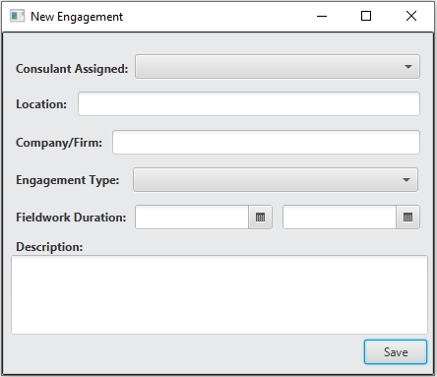

These minimum requirements to create an engagement allow engagements to be queued and coordinated as additional information is gathered regarding the details of the assignment. As more information is gathered and official documentation is obtained, a Consultant can be assigned, and the engagement’s fieldwork can take place.

To manage an existing Engagement record, both the Active Engagements table in the primary SCATS application interface and the “Manage Engagements” menu item from the Engagements -> Manage Engagements menu toolbar, can be used.

By right-clicking on an existing engagement record in the Active Engagements, the engagement details can be observed by selecting “View Engagement”.

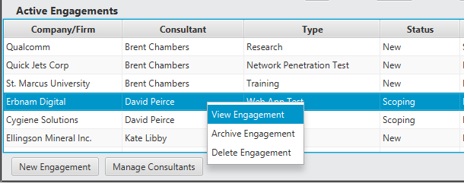

The detailed view of an engagement provides the engagement status, as well as any documents or reports associated with the record.

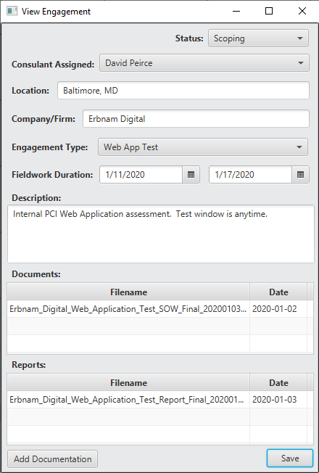

Files associated with an engagement are generally thought of as preliminary or supporting documents, or alternatively, reports that detail the actual work that was performed, including results and analysis. Document types are limited to MS Word Files, MS Excel Files, PDF Files, and Text files. When a file is to be added to the SCATS system and effectively associated with an engagement, the “Add Documentation” button is used at the bottom of the View Engagement dialog to display the “Add New Document” tool.

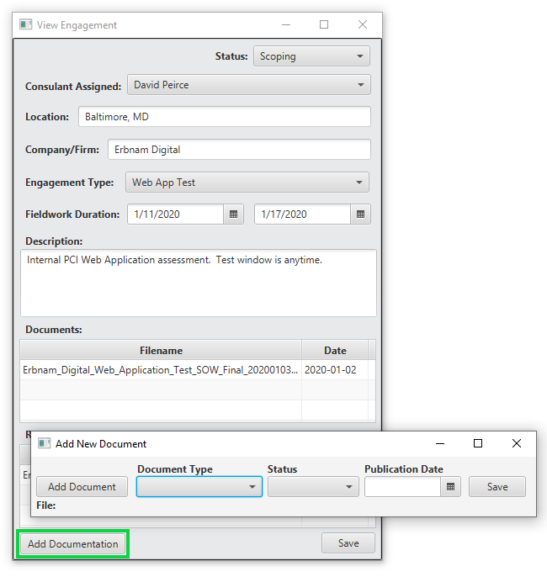

When adding a new document from the “Add New Document” tool, it’s important to note that the file selected will be renamed to maintain a consistent naming convention. To add a new file, browse for the file on the local system to select it. Then provide the document type, the status (Draft or Final), and the original date of publication. Once the SAVE button is clicked, the file will be added to the SCATS system and stored within the /Reports/<CompanyName>/ directory where the SCATS application was originally executed.

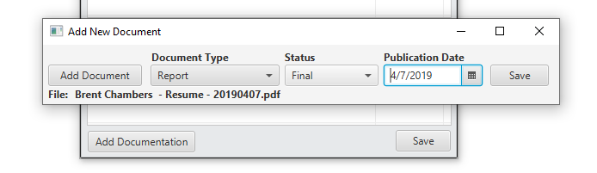

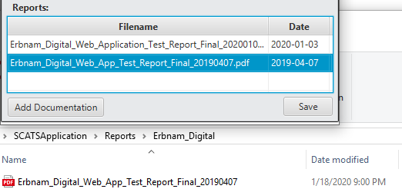

This process ensures all Engagement related documents and reports are stored, tracked, and managed in a centralized location.

### Manage security engagements

To manage both past and present engagements, the **Engagement Management** tool dialog is used. The **Engagements Management** tool dialog can be found by navigating to Engagements -> Manage Engagements, from the main menu toolbar of the SCATS application.

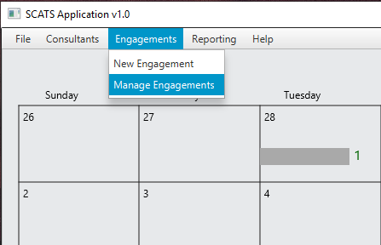

**Engagement Management** provides the ability to view, manage, and search all engagements stored in the SCATS database. Viewing individual engagement details is performed by right-clicking an engagement record and selecting the “View Details” menu item.

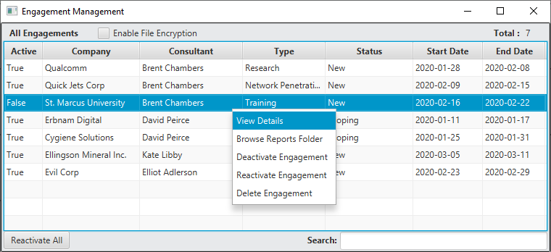

The Active and Inactive status of an engagement is used to effectively “background” an engagement without deleting it from the SCATS database. Inactive security engagements are not tracked on the main SCATS Active Engagements Calendar. Security Engagements can be activated and reactivated by right-clicking on the Engagement record within “Engagement Management” and selecting “Activate” or “Reactivate Engagement”.

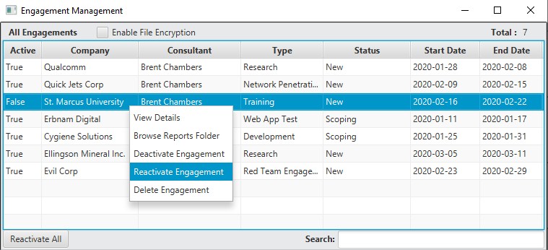

To browse an engagement’s documentation and reports folder, the “Browse Reports Folder” menu item can be selected from the drop-down menu upon right-clicking an individual engagement record. This will launch a file viewer/explorer window, native to the local operating system, if the engagement contains stored documentation.

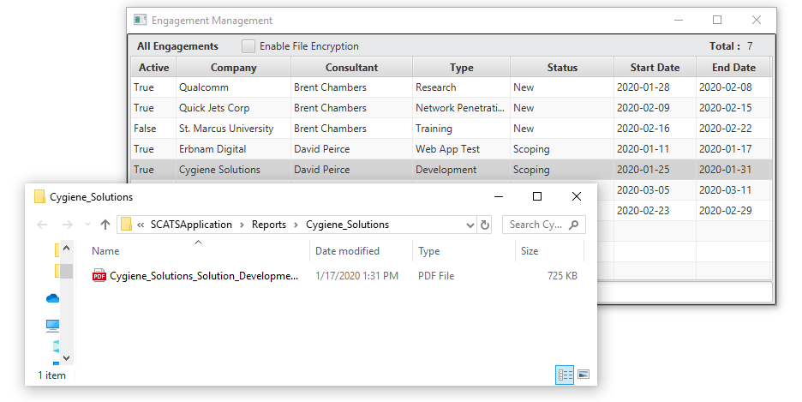

### Generate data reports

The SCATS application provides functionality to generate raw data reports that reflect SCATS engagement, consultant, and certification information. Reports are generated in raw Comma Separated Value (CSV) format. To generate reports, the Reporting menu option from the main SCATS application interface is used. Existing reports include an **All Engagements Report**, an **Active Engagements Report**, an **All Consultants Report**, and an **All Certifications Report**.

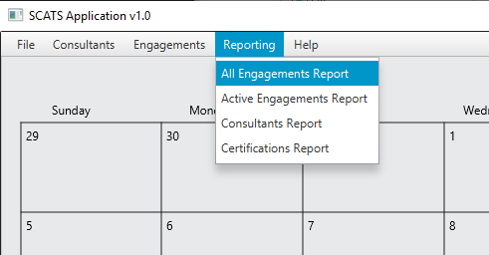

Upon selecting the desired report type, the SCATS application will generate the report, and immediately open the file using the default CSV associated program on the native operating system.

